Project 1 – C# Console Advanced Project
Mini Student Results Processing System

Course: Programming with C# (CE 380)
Lecturer: E. Obu
Submission Date: 24th June, 2026
Student Name: Foster Ametepey
Student ID: SRI.41.008.021.23
Programme: Computer Science and Engineering
Level: 300

1. GitHub Repository
Repository link: https://github.com/Greattero/C-Assignment/

2. Screenshot – Program Running

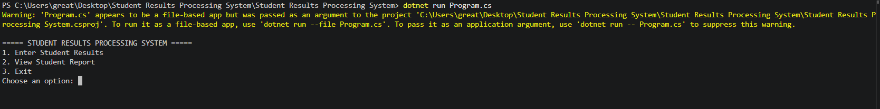

3. Screenshot – Final Output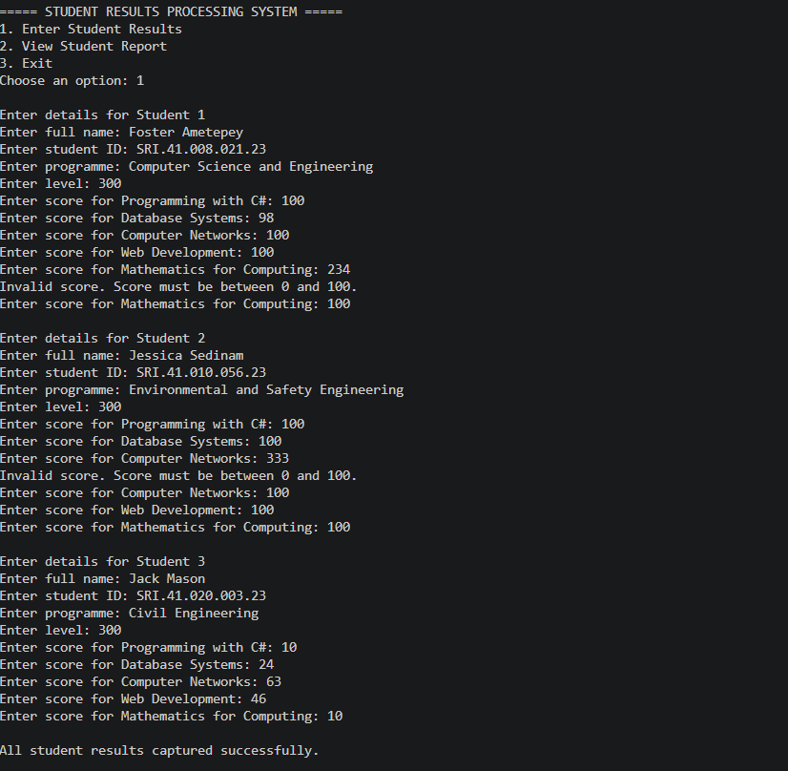

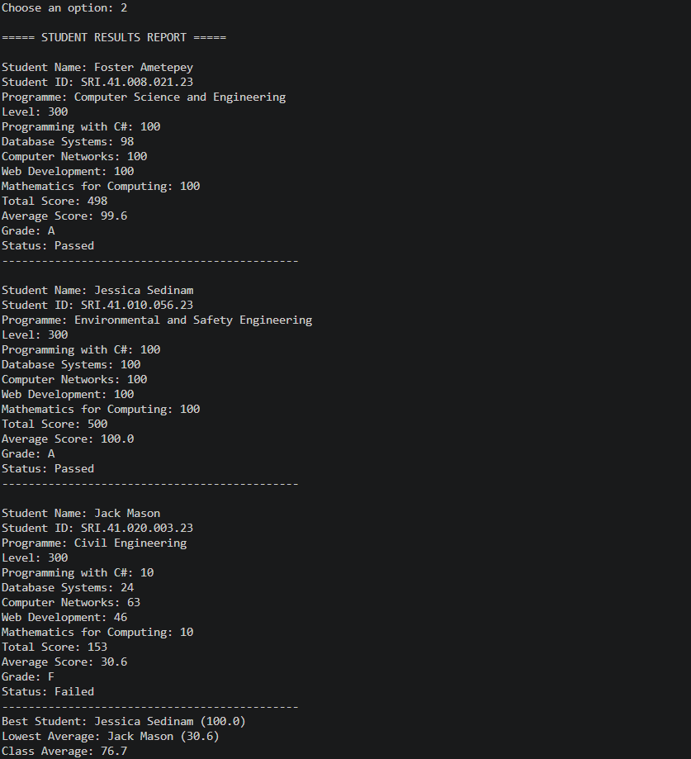

4. C# Source Code (Program.cs)
using System;

namespace StudentResultsProcessingSystem
{
class Student
{
public string FullName { get; set; } = "";
public string StudentId { get; set; } = "";
public string Programme { get; set; } = "";
public string Level { get; set; } = "";
public double[] Scores { get; set; } = new double[5];

public double Total => Scores.Sum();
public double Average => Total / Scores.Length;

public string Grade
{
get
{
double a = Average;
if (a >= 80) return "A";
if (a >= 70) return "B";
if (a >= 60) return "C";
if (a >= 50) return "D";
return "F";
}
}

public string Status => Average >= 50 ? "Passed" : "Failed";
}

class Program
{
static readonly string[] Courses =
{
"Programming with C#",
"Database Systems",
"Computer Networks",
"Web Development",
"Mathematics for Computing"
};

static Student[] students = new Student[3];
static bool hasData = false;

static void Main()
{
while (true)
{
Console.WriteLine();
Console.WriteLine("===== STUDENT RESULTS PROCESSING SYSTEM =====");
Console.WriteLine("1. Enter Student Results");
Console.WriteLine("2. View Student Report");
Console.WriteLine("3. Exit");
Console.Write("Choose an option: ");

string choice = Console.ReadLine() ?? "";
switch (choice.Trim())
{
case "1": EnterResults(); break;
case "2":
if (!hasData)
Console.WriteLine("No data yet. Please enter results first (option 1).");
else
ViewReport();
break;
case "3":
Console.WriteLine("Thank you for using the Student Results Processing System.");
return;
default:
Console.WriteLine("Invalid choice. Please select 1, 2, or 3.");
break;
}
}
}

static void EnterResults()
{
for (int i = 0; i < students.Length; i++)
{
Console.WriteLine($"\nEnter details for Student {i + 1}");
var s = new Student();

Console.Write("Enter full name: ");
s.FullName = Console.ReadLine() ?? "";
Console.Write("Enter student ID: ");
s.StudentId = Console.ReadLine() ?? "";
Console.Write("Enter programme: ");
s.Programme = Console.ReadLine() ?? "";
Console.Write("Enter level: ");
s.Level = Console.ReadLine() ?? "";

for (int c = 0; c < Courses.Length; c++)
s.Scores[c] = ReadValidScore($"Enter score for {Courses[c]}: ");

students[i] = s;
}
hasData = true;
Console.WriteLine("\nAll student results captured successfully.");
}

static double ReadValidScore(string prompt)
{
while (true)
{
Console.Write(prompt);
if (double.TryParse(Console.ReadLine(), out double score) && score >= 0 && score <= 100)
return score;
Console.WriteLine("Invalid score. Score must be between 0 and 100.");
}
}

static void ViewReport()
{
Console.WriteLine("\n===== STUDENT RESULTS REPORT =====");
foreach (var s in students)
{
Console.WriteLine();
Console.WriteLine($"Student Name: {s.FullName}");
Console.WriteLine($"Student ID: {s.StudentId}");
Console.WriteLine($"Programme: {s.Programme}");
Console.WriteLine($"Level: {s.Level}");
for (int c = 0; c < Courses.Length; c++)
Console.WriteLine($"{Courses[c]}: {s.Scores[c]}");
Console.WriteLine($"Total Score: {s.Total}");
Console.WriteLine($"Average Score: {s.Average:F1}");
Console.WriteLine($"Grade: {s.Grade}");
Console.WriteLine($"Status: {s.Status}");
Console.WriteLine(new string('-', 45));
}

// Bonus extras (not scorable, but nice)
var best = students.OrderByDescending(x => x.Average).First();
var worst = students.OrderBy(x => x.Average).First();
double classAvg = students.Average(x => x.Average);
Console.WriteLine($"Best Student: {best.FullName} ({best.Average:F1})");
Console.WriteLine($"Lowest Average: {worst.FullName} ({worst.Average:F1})");
Console.WriteLine($"Class Average: {classAvg:F1}");
}
}
}

